“HM-TRP Setting GUI” User Guide

Note: Before using this tool, make sure HM-TRP module "CONFIG" pin and "ENABLE" pin is connected to ground.

- Open the serial port ：From “COM Setting” controls select the serial port number to communicate、select the baud rate（The default baud rate is 9600bps of HM-TRP module），enter “”again，Open the serial port ，you will find the “COM Setting”controls grayed. Show as below:
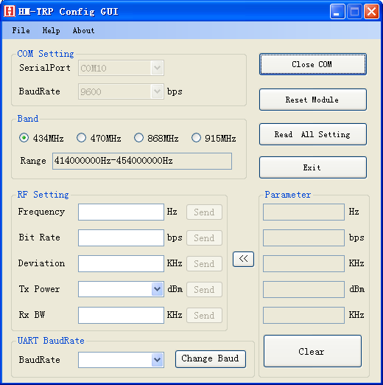
- Reset Module：After open the serial port ，Enter “”，It can Restored to factory default parameters of HM-TRP modules after the success of the reset popup control. Show as below:
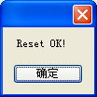
1
- Read All Setting：After open the serial port， “”it can read back and display the parameters of RF, Show as below:
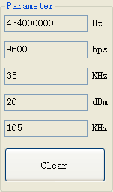
Enter“”can copy the displayed parameters into the corresponding button “RF Setting”; Enter“”can clear the displayed parameters.

- Frequency Setting：User can according to “Band”displayed the Frequency range to set the Frequency, Controls will become red when the setting value is out of range, After finished the setting, Enter“”,If setting succeed，it will popup the dialog“Send OK!”,if not will popup the dialog “Send Fail!”. “Band”select according to the marked on the back of the module’s frequency of HM-TRP. Show as below:
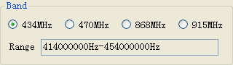

- Bit Rate Setting ： Recommend that users set RF Rate doubled than UART Rate，controls will become red when the setting value is out of range, After finished the setting, enter“”，If setting succeed，it will popup the dialog“Send OK!”,if not will popup the dialog “Send Fail!”.

- Deviation Setting ：Deviation setting must pay attention to set good associated with RxBW. Recommend setting the RxBW more than
2
double Deviation. Controls will become red when the setting value is out of range, after finished the setting, enter “”，If setting succeed，it will popup the dialog“Send OK!”, if not ,will popup the dialog “Send Fail!”

- RxBW Setting：.As above.

- Tx Power Setting：Select the parameter value from the drop-down list. After finish the setting, Enter“”, If setting succeed，it will popup the dialog“Send OK!”, if not ,will popup the dialog “Send Fail”!

- Change UART Baud ：Select the Baud value you want to change ,Enter “”,Can change the serial rate, It will popup below dialog when the setting succeed:
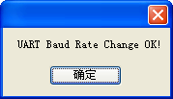

- Historical operating records inquiries: Press the "Log" button in the "Help" menu, it will automatically open the file named "Log.hpf", which records the history of the content and operation of the operating time of the content for the user query. Show as below:
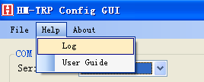

3

HOPE MICROELECTRONICS CO.,LTD  Add: 2/F, Building 3, Pingshan Private Enterprise Science and Technology Park, Lishan Road, XiLi Town, Nanshan District, Shenzhen, Guangdong, China  Tel: 86-755-82973805  Fax: 86-755-82973550  Email: sales@hoperf.com  Website: http://www.hoperf.com  http://www.hoperf.cn | This document may contain preliminary information and is subject to change by Hope Microelectronics without notice. Hope Microelectronics assumes no responsibility or liability for any use of the information contained herein. Nothing in this document shall operate as an express or implied license or indemnity under the intellectual property rights of Hope Microelectronics or third parties. The products described in this document are not intended for use in implantation or other direct life support applications where malfunction may result in the direct physical harm or injury to persons. NO WARRANTIES OF ANY KIND, INCLUDING, BUT NOT LIMITED TO, THE IMPLIED WARRANTIES OF MECHANTABILITY OR FITNESS FOR A ARTICULAR PURPOSE, ARE OFFERED IN THIS DOCUMENT.  ©2006, HOPE MICROELECTRONICS CO.,LTD. All rights reserved.

4

